t-SNE is the best dimensional reduction technique, it is best technique for visualization.

There are many other techniques also, but in most of the cases t-SNE is used.

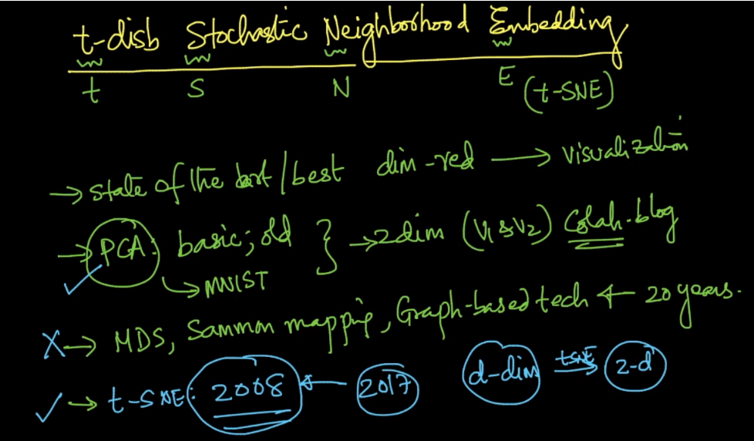

Difference between t-SNE & PCA:

PCA reduces the dimensionality of data by seeking linear projections that can maximize the global variance of the projected data points. PCA thus can preserve the maximum amount of the global information of a data set.

Whereas t-SNE preserves local structure.